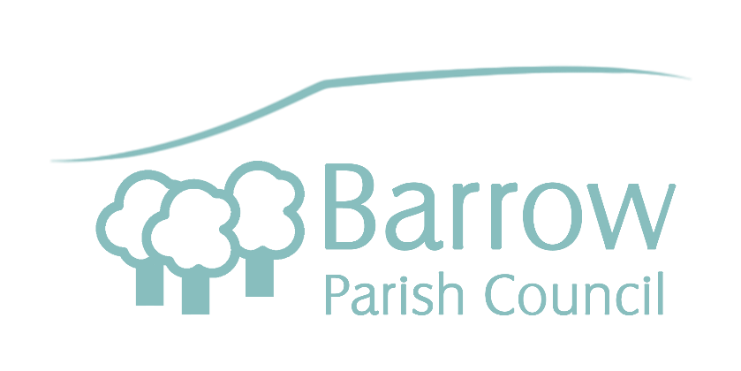

**Barrow Playing Field Regulations**

1. **Dogs are not permitted on the Playing Field, in line with Public Space Protection Orders implemented by Ribble Valley Borough Council. Enforcement action may be taken.**
2. **The Playing Field is owned by Barrow Parish Council. The equipment is inspected for safety on a regular basis. Please report any damage or accidents to the Parish Council by phone on 07582 670562 or via their website at www.barrowparishcouncil.co.uk.**
3. **The Playing Field is for the whole village to enjoy. Please help to keep the site clean and in a good condition. Use the bins provided. There are no funds to replace equipment damaged by vandalism.**
4. **All persons use the play equipment at their own risk. The equipment must be used for its intended purpose only.**
5. C:\Users\Simon\AppData\Local\Microsoft\Windows\Temporary Internet Files\Content.IE5\3DBA7MBG\MC900320842[1].wmf**The play equipment is provided for children aged over 8 years of age. Play equipment suitable for younger children is situated in the park owned by Ribble Valley Borough Council on Washbrook Close, behind Trafford Gardens.**
6. **The Playing Field is a no smoking area, smoking is not permitted on the Playing Field.**
7. **In the interests of safety, glass bottles, alcohol and barbecues are not permitted on the Playing Field.**
8. **In the interests of safety, golf and cricket are not permitted on the Playing Field.**
9. **Tents are not permitted on the Playing Field.**
10. **Be respectful to the neighbours.**
11. **Please keep the gate shut and the entrance clear in case of emergencies.**
12. **Barrow Parish Council and its employees cannot accept responsibility or liability for any claim, loss or damage whatsoever which may arise resulting from the use of this facility, except so far as provided by statute.**

**Say NO to Antisocial Behaviour.**

**Please report any antisocial behaviour to the police immediately**

**on 101.**